Newcastle Fund
Feedback Following Call for Evidence
22nd September 2016 until 12th October 2016

Introduction

In September 2016, the Council launched a Call for Evidence - Shaping the future of the Newcastle Fund - to gather views and ideas on how the Newcastle Fund should look in the future, and to inform a proposal on the future of the Fund for further consultation.

This document provides an overview of feedback received following the Call for
Evidence.

Background and Context

In publishing our Call our Evidence, we have sought to gain a wide variety of views, including those from across the voluntary and community sector (VCS) as well as our public sector and statutory partners (including people representing different divisions across the Council and others who are involved in the allocation of funding to the VCS), as well as communities themselves.

- Newcastle Fund ‘Call for Evidence’ was launched via a Let’s Talk survey which ran from 22nd September 2016 until 12th October 2016.
- We further publicised our Call for Evidence by directly emailing previous applicants of the Newcastle Fund as well as attendees at this year’s Funders Fair, and promoted the survey through the Council’s own News in Brief and Intranet and Internet site.
- Newcastle Council for Voluntary Service also publicised the Call for Evidence to all their members via a range of networks to maximise reach.
- In addition, a workshop was held on 18 October 2016 at the Civic Centre which included representation from those involved in the Fund across the Council’s directorates, alongside representation from the Clinical Commissioning Group and Newcastle Council for Voluntary Service.

In total we received 25 responses, of which 12 were received via the Council’s ‘Let’s Talk’ website (7 registered members and 5 public of which 3 registered without response); the remaining being written responses via email.

Call for Evidence feedback

In presenting this feedback, we have sought to pull out key themes from the responses, as well as provide a cross cutting sample of direct responses received.

Question 1: How should we prioritise the Newcastle Fund investment, especially at a time of financial constraints?

Sample of feedback:

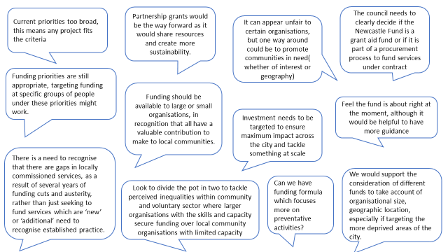

Key themes:

Overall, there were mixed views on the aims and priorities of the Fund and specifically how and who the Newcastle Fund should be targeting.
Responses generally acknowledged that the current priorities are very broad and whilst this enables innovation, it also means that the impact of the funding available may be diluted as the funding is spread across a broad range of projects. Overall, the feedback suggested there would be benefits in greater clarity on the purpose of the Fund as its current breadth means that it provides funding for a range of activities, including core costs, direct service provision, innovation projects, and prevention.
There were also views that grants are funding services that had been impacted by budget reductions, and that funding is bias towards larger organisations, with grass roots community organisation often not applying or not being successful.
There were conflicting views on how the funding should be targeted in the future with three main areas being identified: Geography, People and Issue/ Need.
Geography: Responses suggested a geographical based approach should be considered as this had the potential to have greater impact. There were differing views however on how the areas should be identified - ranging from large areas of the city, to smaller ward and neighbourhood activity. Views also included targeting specific geographies based on deprivation and need. A number of responses stated that this type of approach may also result in more grassroots organisations applying for funding. This approach was also considered by respondents as something that could involve local decision making, such as use of community panel structures and participatory budgeting processes.
Some responses did identify concerns in taking a geographic approach as it may restrict opportunities for groups of people who belong to communities of interest and also impact or limit citywide approaches. Responses also reflected that should the focus be on areas of deprivation or disadvantage, then this may not take account locations where need may not be apparent from the data but where pockets of deprivation may still exist.
People: Some responses suggested the focus should be on specific groups, but again views varied on the identification of disadvantaged and marginalised groups across the age range, although there was a specific focus from some respondents on younger and older people.
Issues/ Need: Some responses put forward examples of key issues that the Fund should focus on, including: loneliness/Isolation, communities of interest, and employment.
There were many comments regarding the idea of apportioning sums of money into separate ‘grant pots’ in order to support increased access for smaller grassroots organisations, with pot sizes ranging from small pots of around £10,000- £15,000, to medium sized pots ranging from £15,000 upwards, to larger pots upwards of £75,000 to undertake specific work at a larger scale. Consortium approaches were identified as being suitable for larger pots.

Question 2: How can the Newcastle Fund better support and encourage asset based approaches (rather than a deficit model) in order to build upon and unlock the potential of communities and residents’ own strengths?

Sample of feedback:
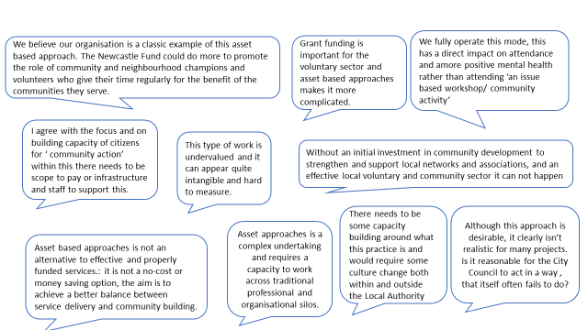

Key themes:

The responses overall were strongly in support of taking an asset based approach but highlighted that this required investment to make a shift in culture, practice and systems (across both the city council and the voluntary and community sector). The role of the Wellbeing for Life Board was highlighted in relation to promoting asset based practice and gathering support at a strategic level across all partners.
A number of responses identified the need for Community Development as an integral element of this change, with some responses setting out some practical steps for implementation. This included applications being viewed in relation to their collaboration, consultative processes, links with other initiatives and projects and how they utilise and develop the resources within a locality.
The feedback received highlighted that this should not be seen as a cost cutting exercise or be in relation to making savings, and that asset based practice would require investment to build the capacity in the city to work in a different way.

Question 3: Could the Newcastle Fund have a greater role in encouraging ‘community action’ and ‘active citizenship’, and how these objectives are defined locally? Is so, what opportunities do you think there are?

Sample of feedback:

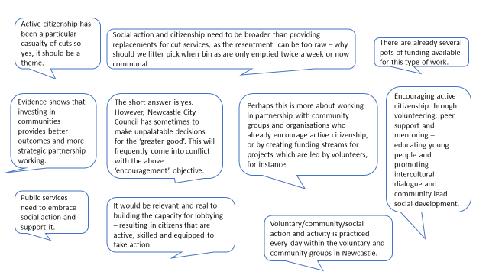

Key themes:

The responses overall supported that the Fund be used to encourage and support ‘community action’ and ‘active citizenship’. Views ranged from supporting greater levels of volunteering and peer support to supporting the capacity for lobbying and involvement in democratic processes. The feedback also highlighted the need to build the capacity to make these changes and rethink how outcomes are measured.

Question 4: Should we review our approach to measuring outcomes achieved as a result of Newcastle Fund investment?

Sample of feedback:
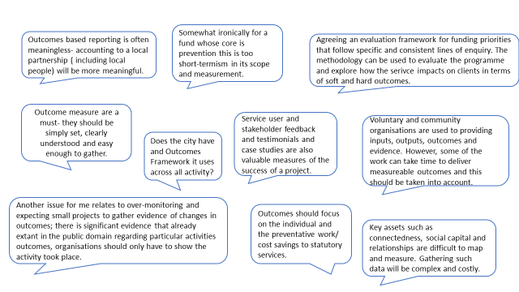

Key themes:
Overall the feedback welcomed a whole scale review on how outcomes from the Newcastle Fund are measured. There were differences in views as to what outcome level should be measured with community, city and locality levels all being suggested. This was also reflected in who should monitor project progress with some views maintaining this should be led by the Council in line with current monitoring and audit processes, to accountability sitting with local panels.

The feedback highlighted the need for outcomes monitoring to be proportionate to the funding allocated and organisational size. There were many comments on the challenges of measuring outcomes, such as wider outcomes resulting from co-production and capacity building, etc.

Responses highlighted a need for time to be given to the VCS to reflect on opportunities to measure these broader outcomes. This also raised questions from respondents about the timescales associated with Fund awards and the ability to measure longer term outcomes achieved given the Fund’s awards are generally more short term (1 and 2 years).

Respondents suggested that a range of information should be considered when measuring outcomes achieved, and that this should include both qualitative and quantitative information. Some specific examples included the use of online platforms, case studies to celebrate events and activities that would demonstrate distance travelled, and not just hard outputs achieved such as number of beneficiaries.

The feedback was supportive of sharing learning across the city and many comments reflected similar types of mechanisms that could be used for monitoring – such as celebration events, short videos, etc.
Question 5: Should we seek to align the priorities and objectives of the Newcastle Fund more closely with other grant programmes? If so which ones.

Sample of feedback: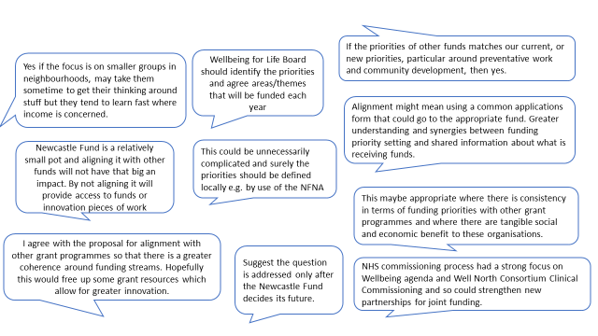

Key themes:
Feedback was divided on the alignment of the Newcastle Fund with other funding streams. Some viewed that by aligning funds it would provide greater clarity, coherence and coordination across the city resulting in tangible social and economic outcomes. In aligning funds, it was viewed that there may also be an opportunity to begin a dialogue with larger funders such as the Big Lottery.

Similarly, there were some concerns raised in relation to aligning funding, and specifically the impact on smaller organisations/groups as it was felt by some respondents that they may be adversely impacted or restricted in accessing funding.

There was considerable focus on the role of the Wellbeing for Life Board and the Newcastle Futures Needs Assessment in setting priorities, both in terms of issues and localities.

Feedback also highlighted some specific potential opportunities, such as opportunities for aligning Newcastle Fund and ward funding priorities, or similarly Your Homes Newcastle’s Housing Revenue Account funding pots, and utilising area based decision making structures.

The responses particularly identified opportunities to align with health funding and priorities, for example CCG Innovation Fund

Overall the feedback suggested that this was an area that needed further exploration and would require new governance structures. Learning could be drawn from other developments such as the Culture Fund.
Question 6: Do you think that the Newcastle Fund should be used as match funding for other initiatives, such as Well North, or Community Led Local Development (CLLD)?

Sample of feedback:

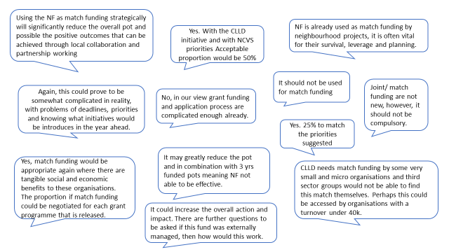

Key themes:
The majority of respondents did not make comment regarding match funding, but of those who did respond, there were slightly more who said they would not like the Newcastle Fund to be considered as match funding to other initiatives.

From those who said no, the reasons included that this would further reduce the Fund, which is already oversubscribed. Particular concerns were raised in relation to smaller organisations and their ability to apply for larger joint pots of funding. The feedback also raised potential impact on smaller organisations who already use the Newcastle Fund as match funding to secure other funding opportunities.

It was acknowledged that aligning priorities and timescales could be complicated.
The issue of capacity of the VCS to know about and understand other initiatives was also raised, as well as the potential risk of further narrowing priorities and targets and therefore organisations being excluded from funding opportunities. It was highlighted in the feedback support would be required to help build the understanding and capacity of the VCS in relation to other initiatives should the Newcastle Fund be used as match funding to these.

For those respondents who thought it would be a positive option, the main reasons provided were that it could increase the total available resources in the city, help develop/ kick start initiatives, and increase the potential for sustainability and longer term outcomes. It was suggested that each initiative would have to be appraised as to the social and economic impact in line with the Newcastle Fund priorities and then funding allocated accordingly. Respondents who were positive about match funding suggested allocating between 25%-50% of available Fund resources.
Question 7: Could we grow the Newcastle Fund using crowd funding? If so, what types of initiatives do you think should be our focus for crowd funding? What other opportunities do you think there are to grow the fund?

Sample of feedback:
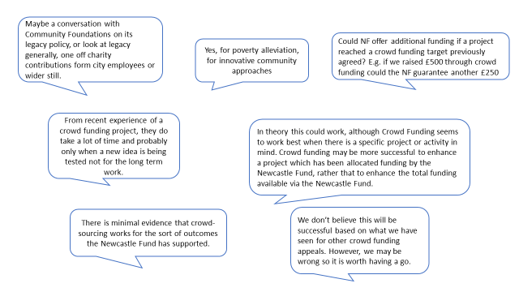

Key themes:

A high percentage of the respondents did not make comment on this area. There was an equal divide of views from those who did respond. Those who felt that the Council should explore opportunities to increase the size of the pot recognised that work would need to be done to identify options, such as targeting large private organisations as part of their cooperate social responsibilities, working with philanthropic individuals or organisations, applying specific levies or penalties which could be directed towards the Fund.

Some of the feedback suggested that crowd funding should be explored as part of the overall process, and that further information would be welcomed on how organisations/ group could link in with this type of opportunity.

Some views expressed that crowd funding is usually targeted at a specific project or group of people, but that the Newcastle Fund could either initiate the crowd funding or provide a top up to projects that meet specific priorities.

Some respondents expressed that they were not in favour of crowd funding and felt that from their experience, the Newcastle Fund may not be an appropriate vehicle and more success may be achieved by organisations appealing for crowd funding directly. It was recognised that crowd funding involves a lot of effort to build momentum, and that one off allocations from the Fund would not necessarily make crowd funding sustainable

Question 8: Are there changes we can make to Newcastle Fund processes to better create the conditions required for different kinds of conversations and ways of working that enable local communities to create change and make positive change?

Sample of feedback:

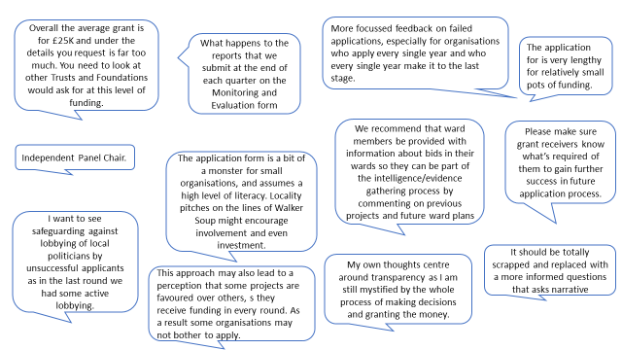

Key themes:
The feedback highlighted a wide range of opportunities in relation to Newcastle Fund processes.

At the front end, feedback generally indicated that the information provided to potential bidders was good in relation to the bidding process and they were clear as to what is expected of them. A number of respondents suggested an opportunity to introduce an ‘expression of interest’ stage, prior to the formal application process. Respondents felt that this might provide a number of positive opportunities including: identifying opportunities for collaborative / partnership bids; ensuring a broad range of bids; reducing the time potential bidders spend on form filling if their project is not deemed appropriate at the ‘expression of interest’ stage; provision of targeted information/signposting to other potential funding opportunities that might be available.

There were many comments on the length and complexity of the application form and that the Council should explore opportunities to streamline this. The feedback received included exploring how previously successful applicants may provide a network of support to new applicants in completing bids and providing support to new applicants. The feedback suggested that consideration be given to ensuring the application and bidding process is commensurate with the amount of funding being requested.

Other feedback focused on opportunities to strengthen feedback to unsuccessful applicants.

Another key theme was the assessment and award process, and particularly the importance of a transparent, fair and independent process

Question 9: Do our processes encourage collaboration of formal and informal strategic alliances? What do you think we could do differently to support collaboration?

Sample of feedback:
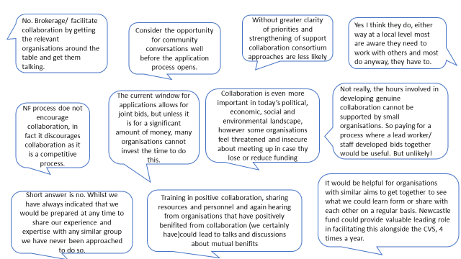

Key themes:
Overall the feedback acknowledged that whilst collaboration is very important in today’s political and economic climate, applicants struggle to collaborate as part of the Newcastle Fund process. The feedback suggests that the Newcastle Fund current processes could be perceived as a barrier to collaboration due to the competitive nature of the Fund.

Timescales and capacity were identified as barriers to collaboration as it often takes longer to develop a joint bid than it does to complete as a single organisational bid.
Although it was acknowledged that recent Funders Fairs provided opportunities for networking and opportunities for potential bidders to identify opportunities for collaboration, respondents were unclear how successful this has been in bringing about collaborations. A number of feedback comments suggested a good starting point to increase collaboration would be the opportunity to have a network or place that is supported by the Council and the NCVS where bids could be developed and shared in the early stages to facilitate joint working.

The feedback identified this as an area that needed to be considered when reviewing the way the Newcastle Fund operates in the future. A number of the comments suggested that collaboration would be stronger and more achievable if funding was devolved to a locality level.

Question 10: Do you think the Council is best placed to enable the opportunities in this section and throughout this document? Would and external community based organisation be better placed to develop and grow these opportunities?

Sample of feedback:
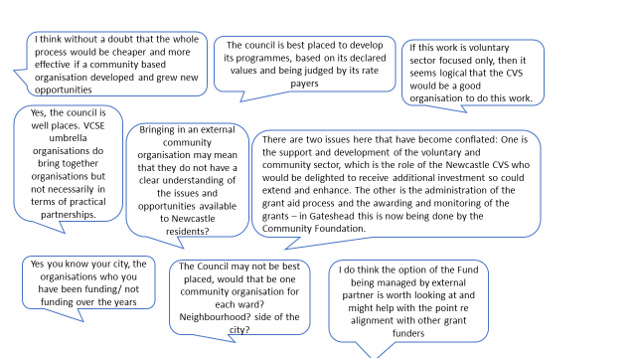

Key themes:
This question received limited feedback. Where feedback was received, respondents were divided with a number of respondents giving reasoning for both retaining Fund administration within the Council, and similarly placing management of the Fund with a third party.

There were views that stated it would be an advantage to have the Fund managed externally including the potential for it to be more cost effective to operate. Some also felt it would have greater independence if it was externally managed, specifically if it was led by a community based organisation/s. Although it was acknowledged that it would be a challenge to find one organisation with sufficient local knowledge at a locality level. However, it was expressed that if an option was to look at more geographical approaches to the Fund, then this could be addressed through links to local funding panels. It was suggested that an external organisation may also open doors to additional opportunities and be well placed to facilitate change in communities.

The feedback highlighted some specific areas the Council could look to as part of exploring these opportunities, including Gateshead’s recent move to grant funding where administration is managed by the Community Foundation, as well learning from the way in which the Council manages Culture Funding.
Other views maintained that the Fund should remain managed by the Council. This was in the context of facilitating collaboration between the public and voluntary and community sector, and in the context of the wider role of the Council and its priorities. Similarly in light of reduced public spending the Council should maintain its responsibility to the fund in delivering the grant process.

Question 11: Do you think there should be a greater role for communities themselves in any part of the Newcastle Fund process? If so, which parts and how?

Sample of feedback:

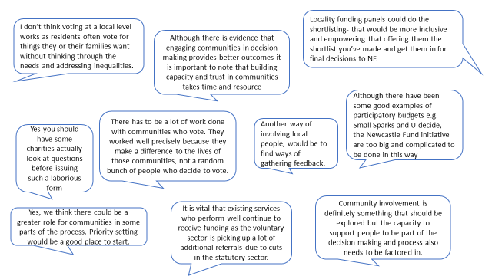

Key themes:
The overall view from the respondents is that communities could have a greater part to play in the Newcastle Fund, including: priority setting (taking account of local needs and ensuring projects tackle issues that are important to communities); involvement in the award process; facilitating collaboration; and in evaluating outcomes.

It was felt by some respondents that a geographical approach would lend itself to greater community participation in the process.

It was clear from the respondents that community involvement should not be just a voting process for personal and vested interests as this could be deemed unequitable as people naturally vote for organisations they know or the people who they feel most deserving or attractive to the public, often leaving projects which deal with issues such as homelessness and with substance misuse issues as less attractive in respect of funding.

The feedback indicated that involvement should include the wider community and specialist groups to ensure a broad range of views are involved.

The feedback indicated that overall community involvement is something that should be explored further and that capacity to support people in all stages of the process is the key to success; similarly, the feedback identified lots of existing work across the city that could be built upon.

Question 12: Do you think we should consider or explore other opportunities in shaping the future of the Newcastle Fund not covered by the questions above?

Sample of feedback:

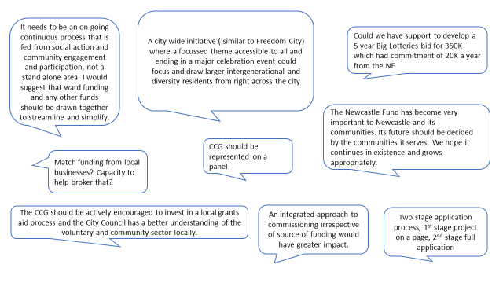

Key themes:
The feedback received generally related to the previous questions in the Call for Evidence.

Next Steps

Proposal for consultation on the future shape of the Newcastle Fund to be published in the New Year.

Contact

Daryll Alder, Commissioning and Procurement Officer, daryll.alder@newcastle.gov.uk

