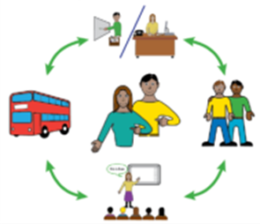**Have Your Say on Newcastle’s Movement Plan Questions**

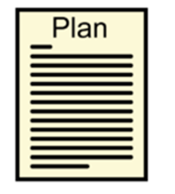Getting places is important for everyone, and it is important we get the conditions right, so we can all benefit from being able to get around easily.

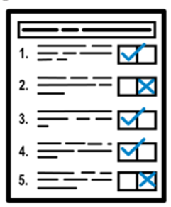We are planning how we can help improve travel by the year 2045. This will be called the **Movement Strategy**. A strategy is a plan to achieve a long-term goal.

Once you have read the Movement Strategy, you can answer the following questions.

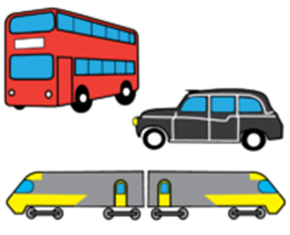By **movement**, we mean **how people move around Newcastle** such as by walking, cycling, using a wheelchair or scooter, buses, Metro, trains, taxi, or driving.

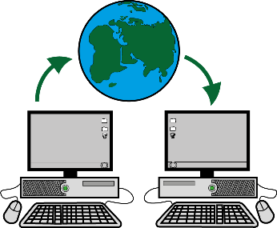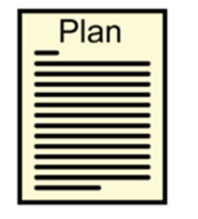We will use your answers to update the Movement Strategy. We will share a summary of these answers later this year.

We will share the Movement Strategy in **2025** at [**newcastle.gov.uk/movement-strategy**](https://newcastle.gov.uk/movement-strategy).

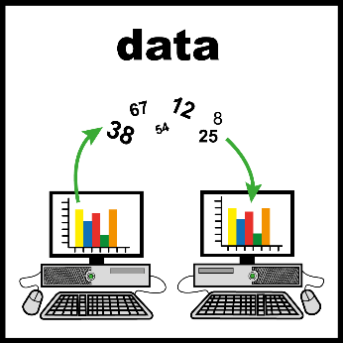We will securely share your information with the company **Eljay Research**. You can read about how they store and use it at [**eljayresearch.com/#right**](https://eljayresearch.com/#right).

If you have any questions, or you need this information in another format, email us at **movement.strategy@newcastle.gov.uk** or call on **0191 278 2767**, leaving your **name** and **phone number**.

# 1. You and Newcastle

## A group of cars and a train Description automatically generatedWhy do you move around Newcastle? Tick one or more.

* I live in Newcastle
* I work in Newcastle
* I study in Newcastle
* I visit for leisure
* I visit for business
* I visit for other reasons

## How often do you use these types of travel in Newcastle?

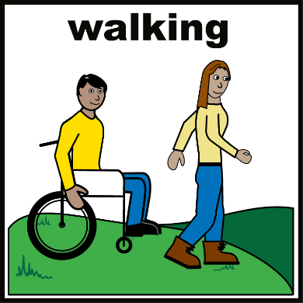Walking or wheeling (such as using a wheelchair)

* Daily
* Weekly
* Monthly
* Less often
* Never

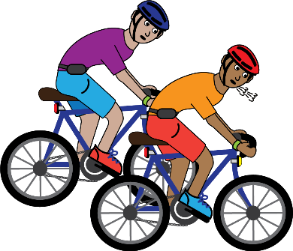Cycling

* Daily
* Weekly
* Monthly
* Less often
* Never

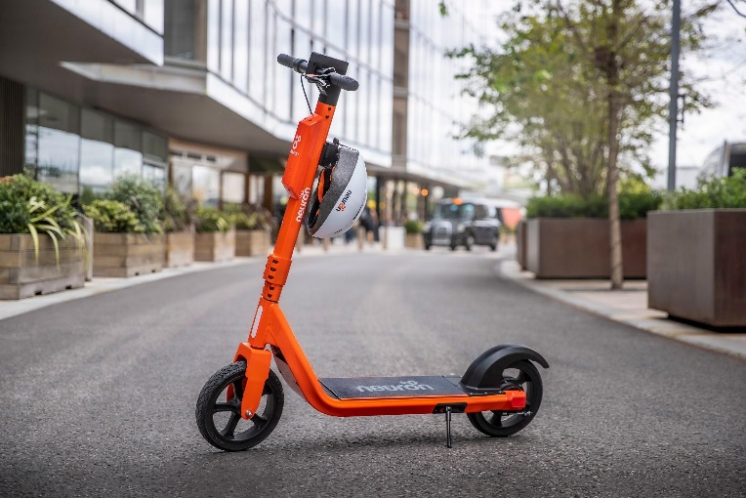E-scooter

* Daily
* Weekly
* Monthly
* Less often
* Never

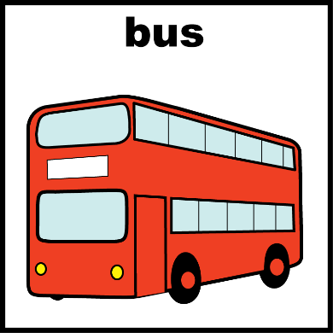Going on the Bus

* Daily
* Weekly
* Monthly
* Less often
* Never



Going on the Metro

* Daily
* Weekly
* Monthly
* Less often
* Never

Car, van, or motorcycle

* 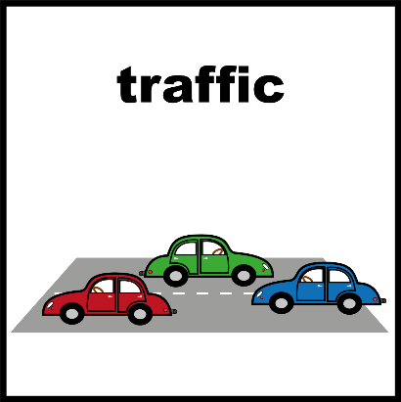 Daily
* Weekly
* Monthly
* Less often
* Never

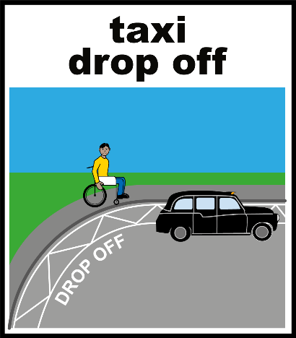Taxi

* Daily
* Weekly
* Monthly
* Less often
* Never

# 2. What is important for Newcastle and transport?

We want to know what you think is important for the future of transport in Newcastle.

## How important or unimportant to you are these for improving transport?

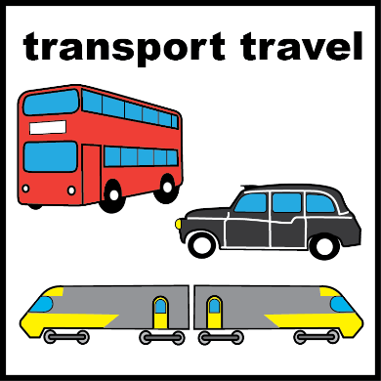Better public transport (buses and the Metro)

* Very important
* Important
* I don’t mind
* Not important
* Not important at all

Making walking and wheeling easier

* Very important
* Important
* I don’t mind
* Not important
* Not important at all

Making cycling easier

* Very important
* Important
* I don’t mind
* Not important
* Not important at all

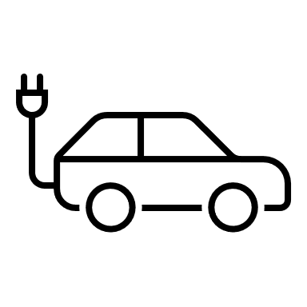Making having an electric car or other electric vehicle easier

* Very important
* Important
* I don’t mind
* Not important
* Not important at all



Improving air quality

* Very important
* Important
* I don’t mind
* Not important
* Not important at all



Making it safer to get around

* Very important
* Important
* I don’t mind
* Not important
* Not important at all

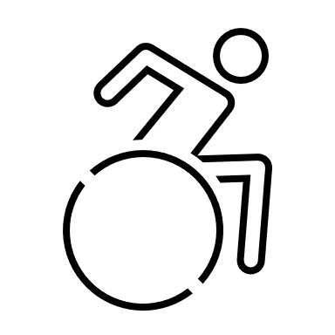

Making it easier for disabled people to get around

* Very important
* Important
* I don’t mind
* Not important
* Not important at all

Having less traffic

* 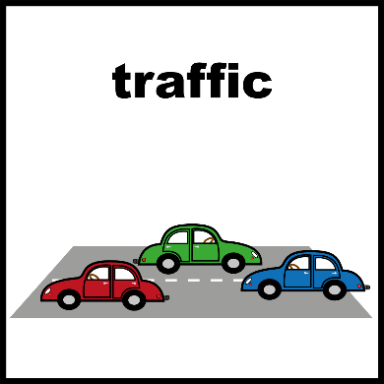 Very important
* Important
* I don’t mind
* Not important
* Not important at all

## 

## Is there anything else that is important to you that should be in the plan? Please tell us about them here:

|  |
| --- |
|  |

# 3. What do you think about what we have put in the Movement Strategy so far?

## About everybodyWe think we should make a transport network in Newcastle that is good for the planet, is for everyone, and helps people be healthy and happy.

## Do you think this is a good idea?

* 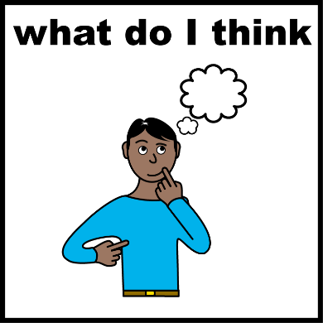 Very good idea
* Good idea
* Not good or bad
* Bad idea
* Very bad idea

## Do you think there is anything missing in what we are hoping to do with transport in Newcastle?

|  |
| --- |
|  |

## share ideasWe have four main ideas for the Movement Strategy. How important or not important do you think these ideas are?



Idea one is **‘Net Zero Newcastle’.** This means having travel that is better for the planet and pollutes less.

*  Very important
* Important
* I don’t mind
* Not important
* Not important at all

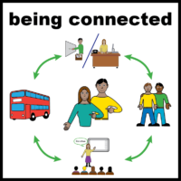Idea two is **‘Sustainable Growth’**. This is making sure that businesses are connected to people. It also means making sure that people can get to work, school, college, and university more easily.

*  Very important
* Important
* I don’t mind
* Not important
* Not important at all

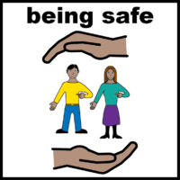

Idea three is **“healthier, active and safe”.** This means people are moving more and kept safe when moving around the city.

*  Very important
* Important
* I don’t mind
* Not important
* Not important at all

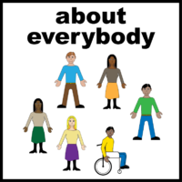

Idea four is to make Newcastle more **“inclusive, efficient and connected”.** This means making sure transport works for everyone.

* Very important
*  Important
* I don’t mind
* Not important
* Not important at all

## Are there any other ideas that we should have in the Movement Strategy that are not in these four ideas?

|  |
| --- |
|  |

# What do you think about the principles and actions in our proposed Movement Strategy?

As you saw in the last section, we are proposing four ideas for making transport in Newcastle better. We want to ask you what you think about these ideas.

## Net Zero Newcastle

We want to make transport in Newcastle better at facing problems made by climate breakdown. We want to:

* + - * Make roads that can handle bad weather better.
* Have more places that collect rainwater, so we have less flooding.
* Have more sheltered and shaded streets.

Do you think this is a good idea?

* Very good idea
* Good idea
* Not good or bad
* Bad idea
* Very bad idea

We also want to have cars, vans, buses, and lorries that do not pollute as much. We want to:

* Have more electric charging points
* Use more electric vehicles in the council
* Look at how much parking costs
* Get more delivery people to use vehicles that are better for the environment.

Do you think this is a good idea?

* Very good idea
* Good idea
* Not good or bad
* Bad idea
* Very bad idea

We want more people to walk, wheel, cycle, and use public transport. We want to:

* Help public transport run on time
* Make walking and cycling easier by having more cycle parking, better signs, and making roads better for cyclists and people walking and wheeling.

Do you think this is a good idea?

* Very good idea
* Good idea
* Not good or bad
* Bad idea
* Very bad idea

## A person in a wheelchair and a person walking Description automatically generatedSustainable Growth

We want people to get to work, school, parks, and shops. We want to:

* A couple of people riding bicycles

  Description automatically generatedMake it easier for people to walk, wheel, and cycle.
* Help workplaces get more people to travel by walking, wheeling, cycling, or by public transport.
* Try and get companies who decide how much the bus and Metro cost to make these cheaper.

Do you think this is a good idea?

*  Very good idea
* Good idea
* Not good or bad
* Bad idea
* Very bad idea

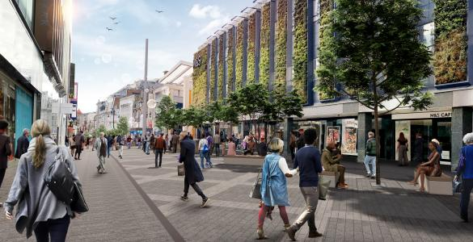We want to make public spaces better. We want to:

* Make shopping areas better so more people go there.
* 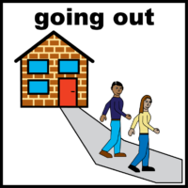Have rules for how we make streets so that they are more accessible for everyone
* Make sure parking is controlled in public spaces, but also make sure there is enough disabled parking.

Do you think this is a good idea?

* Very good idea
* Good idea
* Not good or bad
* Bad idea
* Very bad idea

We want to make more housing and places for people to work. We want to:

* Make bus services, cycling paths, and footpaths better around new housing
* Have less people driving
* Keep people walking, wheeling, and cycling safe when things are being built
* Make sure we are using the sides of our roads
* Asking for better bus services
* Looking at where cars, vans and other vehicles should be able to go.

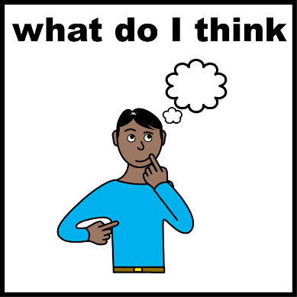Do you think this is a good idea?

* Very good idea
* Good idea
* Not good or bad
* Bad idea
* Very bad idea

**Healthier, active, and safer Newcastle**

We want to make streets safer. We want to:

* Put things in place to make sure less car crashes happen.
* Make sure streets are safe and accessible.
* Show more people how to be safe when traveling.
* Work with schools.

Do you think this is a good idea?

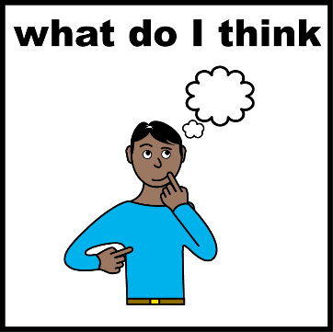

* Very good idea
* Good idea
* Not good or bad
* Bad idea
* Very bad idea

We want more people to be active. We want to:

* A couple of people riding bicycles

  Description automatically generatedHelp more people walk, wheel or cycle.
* Have more car clubs, where people share cars, and places for people to borrow bikes and scooters.
* Make it easier for people to walk, wheel, cycle and use public transport.

Do you think this is a good idea?

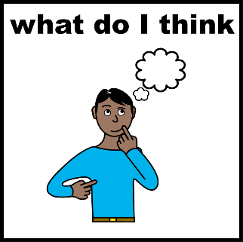

* Very good idea
* Good idea
* Not good or bad
* Bad idea
* Very bad idea



We want cleaner air. We want to:

* Have less cars and vans and other vehicles.
* Have more electric cars, vans and other vehicles in the city.

Do you think this is a good idea?

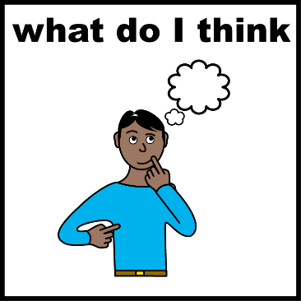

* Very good idea
* Good idea
* Not good or bad
* Bad idea
* Very bad idea

**Inclusive, connected and efficient Newcastle**

## Designing for all

We want to make sure everyone can access streets and spaces. We want to:

* Have more step-free access, wider footpaths, and better disabled parking.
* Put people who walk and wheel first.
* Have parking for people who need it most.

Do you think this is a good idea?

* Very good idea
* Good idea
* Not good or bad
* Bad idea
* Very bad idea

We want to connect places better. We want to:

* Make places around bus stops and Metro stations nicer
* Put buses and cyclists first on main road
* Work with people who run buses and the Metro to make these better
* Make it easier for people to walk, wheel, cycle and use the bus or Metro
* Try and cut down on the amount of traffic in places where people live.

Do you think this is a good idea?

* Very good idea
* Good idea
* Not good or bad
* Bad idea
* Very bad idea

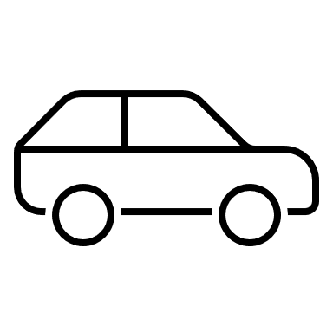We want to have fewer cars. We want to:

* Work with places nearby, like North Tyneside and Gateshead, to look after how much traffic there is
* Look at who is put first on roads.

Do you think this is a good idea?

* Very good idea
* Good idea
* Not good or bad
* Bad idea
* Very bad idea

## A person and person with mouth and mouth Description automatically generatedIf there are any additional actions you think we should take to improve transport in Newcastle please tell us about them here:

|  |
| --- |
|  |

## A person and person with mouth and mouth Description automatically generatedIf you have any final comments or suggestions about the proposed Movement Strategy, please tell us about them here:

|  |
| --- |
|  |

# About you5. About you

Finally, some questions about you. We are asking these questions so that we can learn a bit more about the different needs and views about transport of different groups of people in Newcastle. We will keep your answers private, and only use them for this purpose. You cannot be identified from your answers.

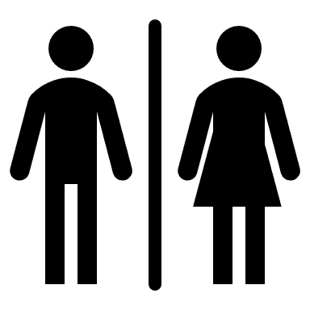**What is your gender?**

* Female
* Male
* Other: ______________________
* Don’t want to say

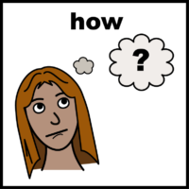**What age group are you in?**

* Under 16
* 16 – 24
* 25 – 34
* 35 – 44
* 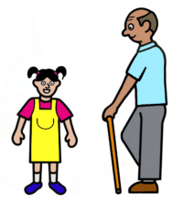45 – 54
* 55 – 64
* 65 – 74
* 75 – 84
* 85+
* Don’t want to say

**Do you have any children under the age of 16 living in your house?**

* Yes
* No
* Don’t want to say

**Are you disabled?**

* Yes
* No
* Don’t want to say

**What is your ethnic group?**

* 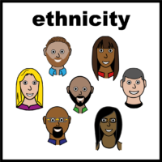Asian or Asian British
* Black, Black British, Caribbean, or African
* Mixed or multiple ethnic groups
* White
* Other
* Don’t want to say

**What is your sexual orientation?**

* 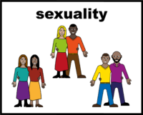Bisexual
* Gay or Lesbian
* Heterosexual / Straight
* Other
* Don’t want to say

## What is your religion?

* Buddhist
* Christian
* Hindu
* Jewish
* Muslim
* Sikh
* No religion
* Other
* Don’t want to say

## address V2

|  |
| --- |
|  |

## What is your postcode?

## Are you… (tick any that are you)

* Working
* Retired
* Studying
* Looking after your home or a family member
* Long term sick or disabled
* Other
* Don’t want to say

**What is your household income?**

* 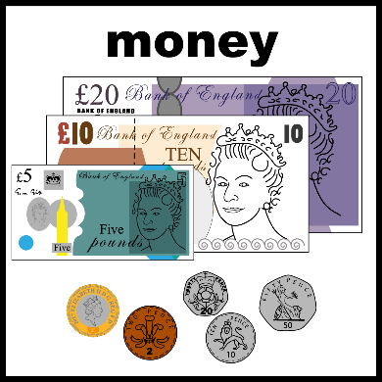£0 – 20,000
* £20,001 - £40,000
* Above £40,000
* Not sure
* Don’t want to say

6. Do you want to help us more?

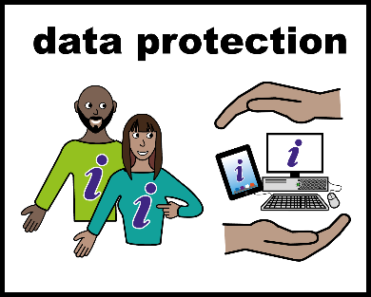We will store this information securely and separately from your answers to the earlier questions in line with the **UK General Data Protection Regulation** (UK GDPR).

We only use it to ask you if you want to take part in future engagement about the Movement Strategy. We will not share it with anyone else.

If you have questions about this or want us to delete your information, please email us at: **movement.strategy@newcastle.gov.uk**

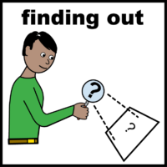**How did you hear about this survey?**

* Council website
* Letter
* Social media
* Event or pop up
* Let’s Talk Newcastle Online
* Other

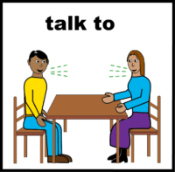

**Would you be interested in telling us more in a conversation?**

* Yes
* No

**If you do, please tell us your contact information, so your name and email address or phone number:**

|  |
| --- |
|  |

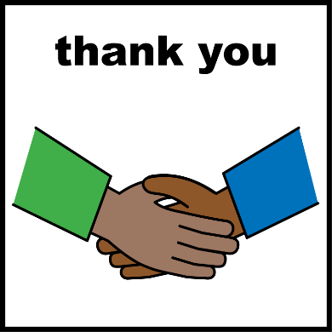**Thank you for completing this survey. Your views are important to help us create a better transport network for Newcastle. You can find out more online at** [**newcastle.gov.uk**](http://www.newcastle.gov.uk)**/movement-strategy**